**UID-4**

Familiar and Unfamiliar icons  
  
**Familiar:**  
**Familiar navigation** consists of commonly used design elements and interaction patterns that users regularly encounter across websites and applications. These elements are intuitive and predictable, making them easy to use without requiring additional learning. Examples include the search bar, navigation menu, login/logout buttons, and edit/save functions.

**Unfamiliar:**  
**Familiar navigation** consists of commonly used design elements and interaction patterns that users regularly encounter across websites and applications. These elements are intuitive and predictable, making them easy to use without requiring additional learning. Examples include the search bar, navigation menu, login/logout buttons, and edit/save functions.

**Familiar Navigation Elements**

* **Standard Username and Password Fields: Users enter their login credentials using well-known input fields, ensuring a smooth authentication process.**
* **Clearly Positioned Login Button: Placed directly below the input fields, following a common design pattern seen in most applications.**
* **Easily Accessible Edit Profile Button: Allows users to quickly update their personal information without unnecessary navigation hurdles.**

**Unfamiliar Navigation Elements**

* **Hidden Category Menu: Instead of a traditional tab bar, the navigation starts with a category icon in the top-left corner, which reveals a sidebar menu upon tapping.**
* **Sidebar Navigation: The second screen introduces an overlay sidebar menu, which is a less conventional navigation method, allowing access to various sections like analytics, feedback, and leaderboards.**
* **Leaderboard UI with Gamification: The third screen uses a unique step-based leaderboard layout instead of a simple list, enhancing user engagement through visual hierarchy and ranking representation.**

**Familiar Design:   
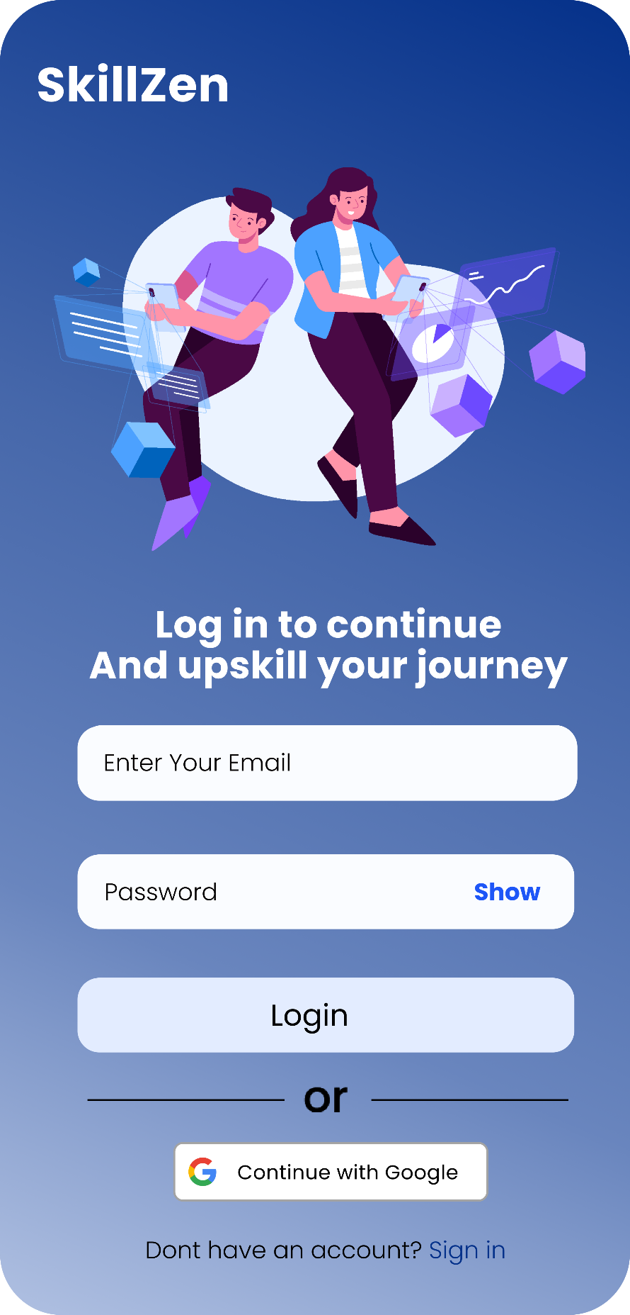  
UnFamiliar Design:  
